Model Provenance Verification Framework for Pre-trained Machine Learning Models

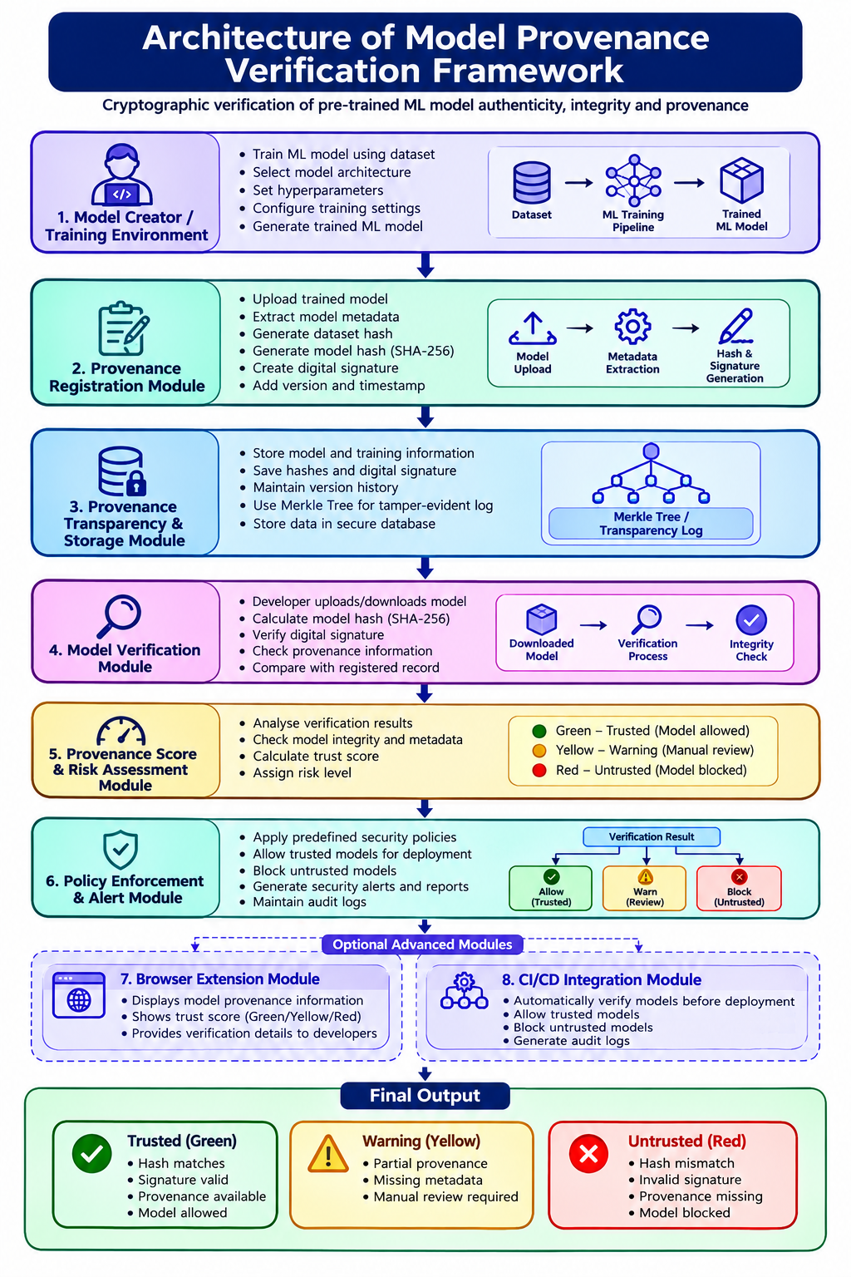
ARCHITECTURE 2:

